ADVERTISEMENT – REQUEST FOR PROPOSAL

DETROIT REGIONAL CONVENTION
FACILITY AUTHORITY
One Washington Blvd
Detroit, MI 48226
(313) 877-7974
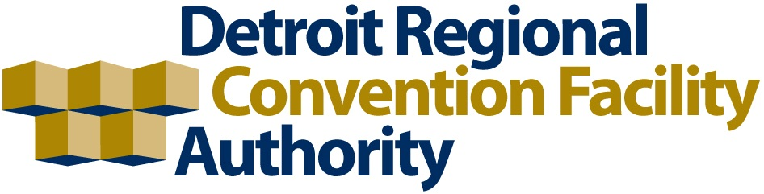
Hazardous Materials Abatement Services | RFP: 21.2425 CIP

Notice is hereby given that the Detroit Regional Convention Facility Authority (DRCFA) is soliciting competitive proposals for Hazardous Materials Abatement Services per the terms and conditions of the Request for Proposal.

Bid documents may be obtained on or after April 17, 2025 at the following website: www.bidnetdirect.com/MITN. Prospective bidders must first log in to the site and search the “Open Solicitations” tab for this project. Bidnet Direct’s customer service and support phone number is 800-835-4603 to help you navigate the site and register your entity (at no cost) if needed.

Bidders are encouraged to attend the pre-bid meeting on April 30, 2025 at 2:00 pm. at Huntington Place Convention Center, One Washington Blvd, Room 352, Detroit, MI 48226 OR via Teams. Onsite parking is available for $25/vehicle. Questions may be directed to Mr. Steve Domonkos at sdomonkos@drcfra.org AND Purchasing Department at purchasing@drcfa.org no later than May 2, 2025.

Proposals shall be prepared in accordance with specifications outlined in the RFP. Submittals shall be on forms furnished in the RFP. Proposers must provide Iran Linked Business disclosure in compliance with Public Act 517 of 2012 and attach this information to the bid proposal. The bid proposal must be accompanied by a sworn and notarized statement that their business is NOT an Iran Linked Business.

A bidder will be permitted to withdraw his bid, unopened, after it has been submitted if so requested prior to the time specified above for opening of proposals.

Bid submittals must be emailed to purchasing@drcfa.org OR sealed in a mailed envelope or hand delivered to Detroit Regional Convention Facility Authority, One Washington Blvd, Detroit, MI 48226, Attention: Ms. Laura Harrington, Purchasing Director. Proposals must be received on or before May 15, 2025 at 2:00 p.m. local time. The DRCFA will not consider nor accept a proposal received by the DRCFA after the deadline date and time specified in RFP documents. Late bids shall not be opened nor returned to bidder. Faxed bids shall not be accepted for any reason.

Proposals will be publicly opened on May 15, 2025 starting at 2:00 p.m., local time, at Huntington Place, One Washington Blvd, Detroit, MI 48226. Interested parties may join in person in Conference Room 352. RFP evaluation and award subsequently will be made by DRCFA’s Board of Directors. The successful bidder(s) shall be required to enter into a contract with the DRCFA.

The DRCFA reserves the right to reject any or all bid proposals, either in whole or in part, to split the award, to award to other than the low cost bid, to waive any informalities or irregularities, and to accept bid alternates. The DRCFA also reserves the right to award a contract in any manner deemed by the DRCFA, in the DRCFA’s sole discretion, to be in DRCFA’s best interests.

Date: Authorized Signature:
4/17/2025 Laura M. Harrington
Laura Harrington CPPO, CPPB
Purchasing Director

